 01AI0506 | DAA Lab Manual Department of AI, ML & DS FACULTY OF TECHNOLOGY
Practical: 4
Implementation and Time analysis of factorial program using iterative and recursive method
Aim: To Implement and Time analysis of factorial program using iterative and recursive
method
Algorithm:
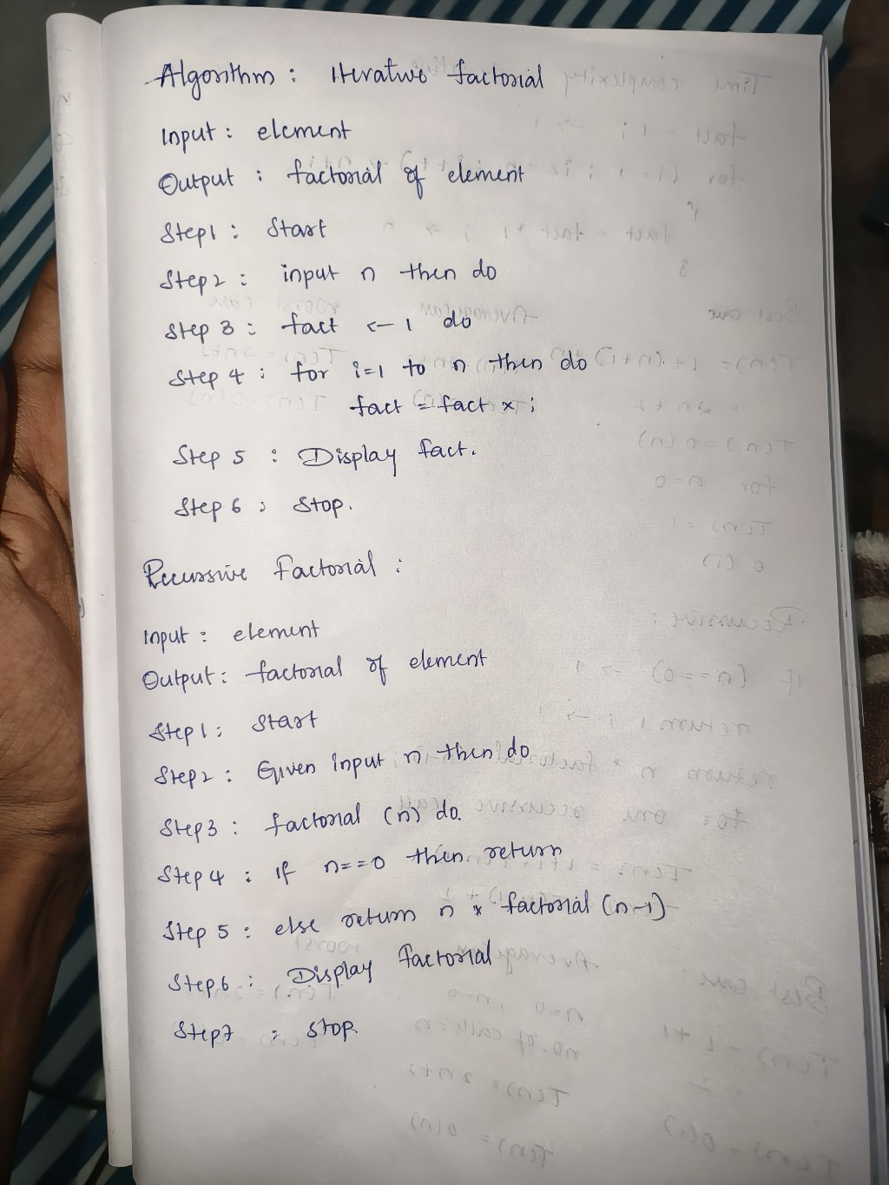
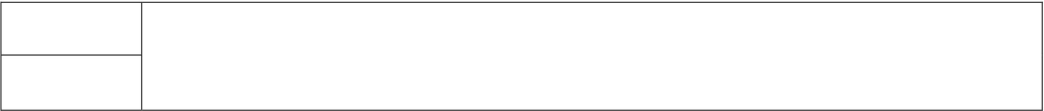

 01AI0506 | DAA Lab Manual Department of AI, ML & DS FACULTY OF TECHNOLOGY
Program:
Iterative Code
#include<iostream>
using namespace std;
int factorial(int n){
int fact = 1;
for(int i = 1; i <= n; i++){
fact = fact * i;
}
return fact;
}
int main(){
int n;
cout<<"enter the number ";
cin>>n;
cout<<"factorial of the number is: "<<factorial(n);
return 0;
}
Recursive Code
#include<iostream>
using namespace std;
int factorial(int n){
if(n==0){
return 1;
}
else{
return n*factorial(n-1);
}
}
int main(){
int n;
cout<<"enter the number ";
cin>>n;
cout<<"factorial of the number is: "<<factorial(n);
return 0;
}

 01AI0506 | DAA Lab Manual Department of AI, ML & DS FACULTY OF TECHNOLOGY
Output:
Iterative Method
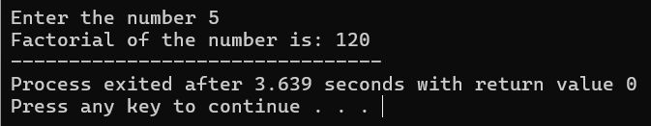
Recursive Method
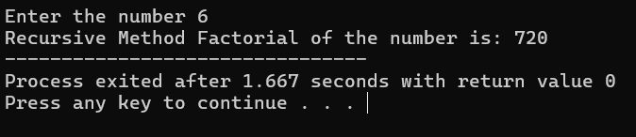
Time Complexity:
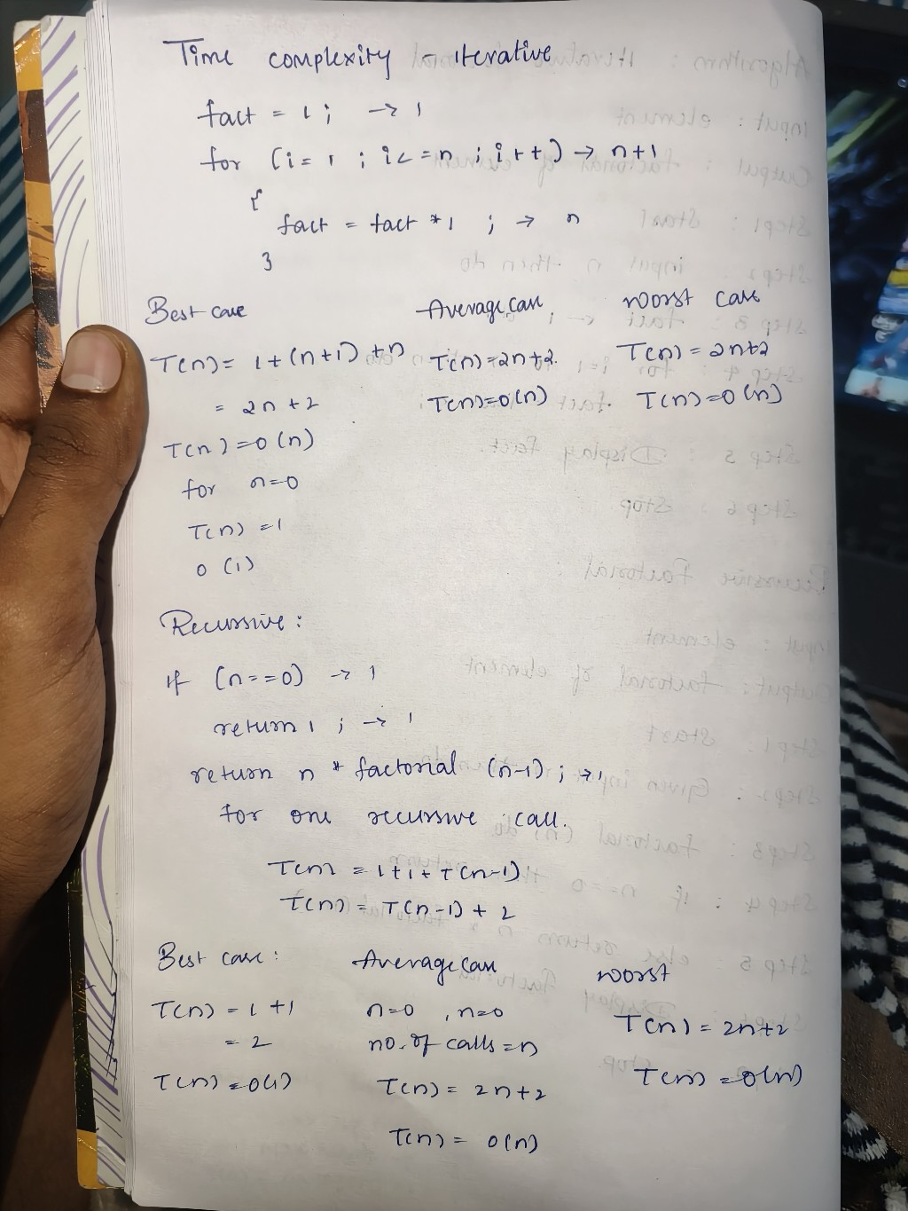
Conclusion:
Hence, the Max-Heap Sort algorithm was successfully implemented and executed. It was observed that Heap Sort gives a time complexity of O(nlogn) in the best, average, and worst cases. It is an efficient sorting technique and works well for sorting large sets of data.

